**SE 421 Fall 2021 Assignment 1 (15 points), Assigned: 8/23, due: Wednesday, 9/1**

**Name (Last, First): Ogbondah, Chimzim**

**Submission**: (a) The answers should be typed. (b) The first page should include the top two lines with your last and the first name. (c) The question should be included for every answer. (d) The file should be named HW1-lastname-firstname. Submit the homework through Canvas.

Similar examples are in the lecture notes. The examples were further elaborated during lectures. Read the notes carefully. In case you missed any lecture, listen to it. Studying notes and attending lectures would be very helpful for the homework.

The submission and late policy are as described in the syllabus.

**Problem 1 (4 points):** The table describes execution behaviors of S. Give the graph GC(S), the compact representation of execution behaviors of S.

n = 3, A = {a1, a2, a3, a4, a5, a6, a7, a8}

|  |  |  |  |
| --- | --- | --- | --- |
| **V3** |  |  | **SA** |
| 1 | 1 | 1 | a1 a2 a3 a4 a5 a8 |
| 1 | 1 | 0 | a1 a2 a3 a4 a6 a8 |
| 1 | 0 | 1 | a1 a2 a3 a4 a7 a8 |
| 1 | 0 | 0 | a1 a2 a3 a4 a7 a8 |
| 0 | 1 | 1 | a1 a2 a3 a5 a8 |
| 0 | 1 | 0 | a1 a2 a3 a6 a8 |
| 0 | 0 | 1 | a1 a2 a3 a7 a8 |
| 0 | 0 | 0 | a1 a2 a3 a7 a8 |

**Problem 2 (2 points):** How many paths where a red node is not followed by a green node?

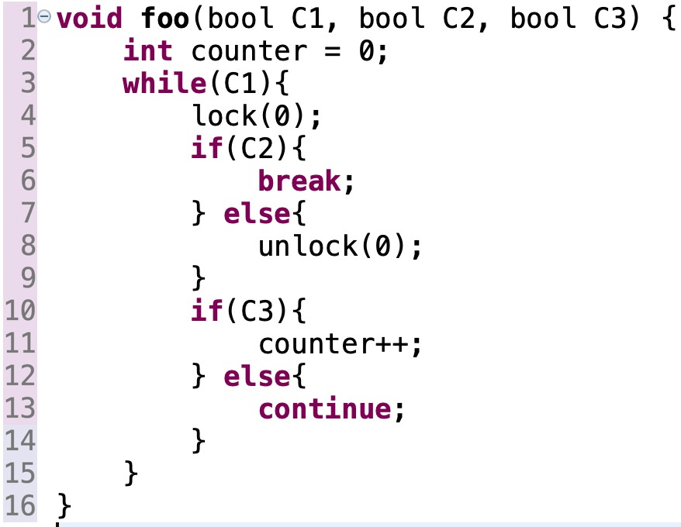

|  |  |  |
| --- | --- | --- |
| Program corresponds to S |  | GC(S) |

**Answer:** There is 1 path and that is when C2 is true otherwise it hits a green node

**;tg**

**Problem 3 (4 points):** How many paths are there in the graph? Write all the paths. For example, e1 e3 e9 e11 e13 is a path.

**Answer: 12 Paths = { (**e1e3e9e11e13), (e1,e3,e9,e12,e14), (e1e4e7e9e11e13), (e1e4e7e9e12e14), (e1e4e8e10e11e13), (e1e4e8e10e12e14), (e2e6e10e11e13), (e2e6e10e12e14), (e2e5e8e10e12e14), (e2e5e8e10e11e13), (e2e5e7e9e12e14), (e2e5e7e9e11e13) }

**Problem 4 (5 points):** Which one is the correct algebraic expression?

1. (e1 e3 + e2 e4) (e5 + e6) (e7 e9 + e8 e10) (e11 + e12)



e1



e2



e3



e4



e5



e6



e7



e8



e9



e10



e12



e11

1. (e1 e3 + e2 e4) (e5 (e7 e9 + e8 e10) + e6) (e11+e12)
2. (e1 e3 + e2 e4) (e5 (e7 e9 + e8 e10) e11 + e6 e12)
3. (e1 e3 e5 (e7 e9 + e8 e10) + e2 e4 e6 (e11+ e12)

**Problem 5 (Bonus 3 points):** Write the execution behaviors for which L is not followed by U. U may precede L.

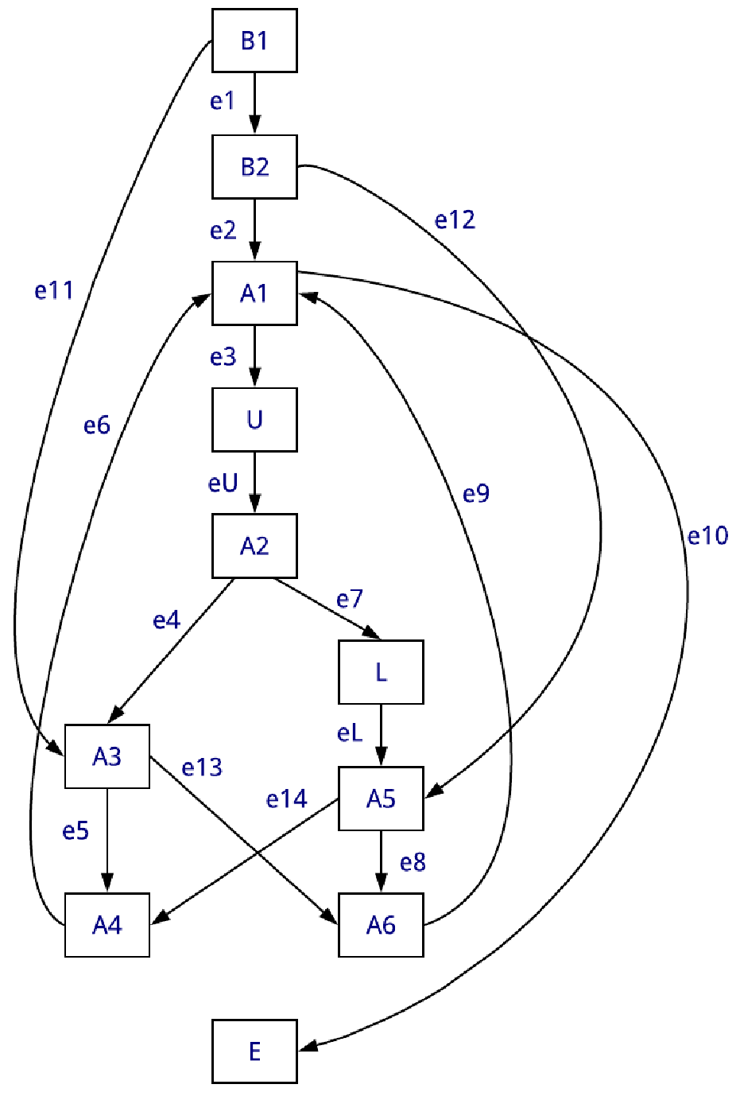U

L